Augustine Campaign System
Complete Testing Guide
How ICPs, Products, Offers, Campaigns, Leads, and Journeys Connect
An end-to-end testing manual for the Augustine Institute outreach automation

1. Introduction
This document is a complete testing guide for the Augustine Campaign System. It covers the full data hierarchy (ICP → Product → Offer → Campaign → Lead → Journey), explains how these entities relate to each other, walks through the end-to-end testing flow, and provides example test data you can use to verify the system works correctly.
Who this is for:
- Anyone performing manual testing of the Augustine outreach automation
- Team members onboarding to the project
- Stakeholders who need to understand how the system works end-to-end
What you will learn:
- How the data entities relate to each other (with examples)
- The complete testing flow from setup to verification
- Sample test data for ICPs, Products, Offers, and Leads
- What to check at each step and how to identify bugs

2. System Overview
The Augustine Campaign System is built on three core tools that work together:
Tool | Role
Admin UI | Next.js dashboard where the team creates and manages all entities — ICPs, products, offers, campaigns, leads, journeys
N8N | Automation engine — sends outreach emails, processes replies, updates lead statuses
Slack | Real-time alerts — notifies the team when important events happen (replies, clicks, status changes)

3. Complete System Flow
The diagram below shows how everything connects from manual setup all the way to automated lead handling and Slack alerts.
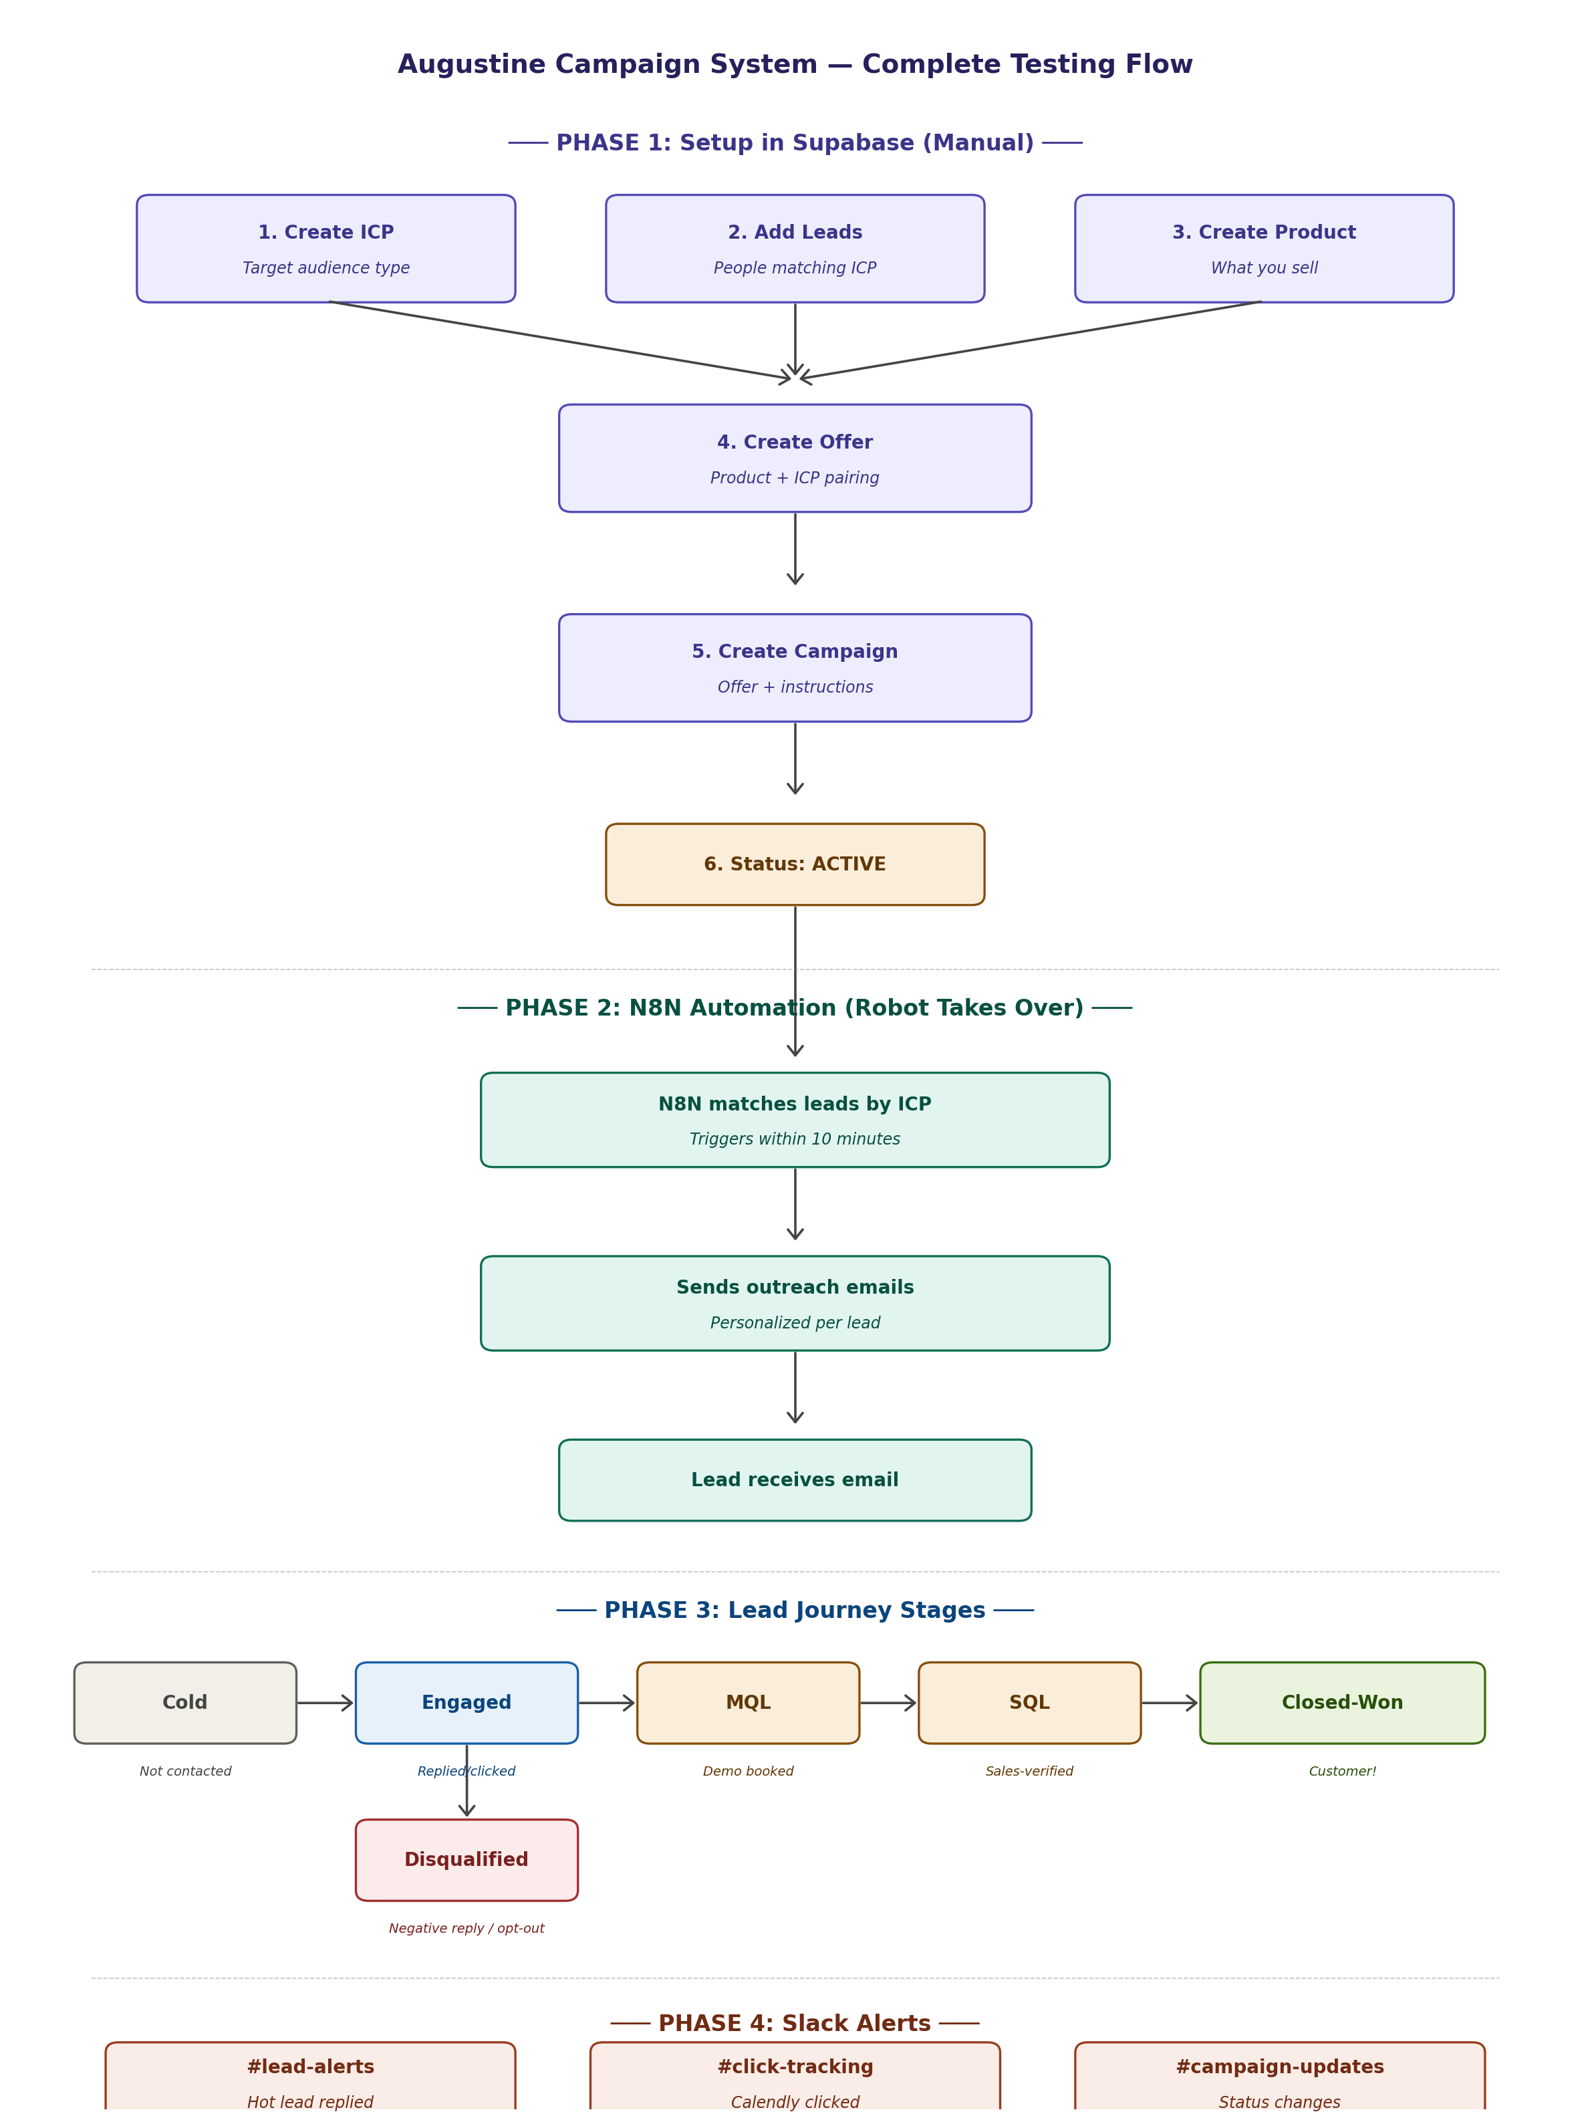
How to read this diagram:
The flow is divided into 4 phases:
- Phase 1 (Purple): Manual setup work done by humans in the Admin UI
- Phase 2 (Teal): Automated work done by N8N once a campaign goes live
- Phase 3 (Multi-color): Each lead's journey through stages (Cold → Engaged → MQL → SQL → Closed-Won)
- Phase 4 (Coral): Slack alerts that fire at key moments to notify the team

4. Understanding the Data Entities
Before testing, it's crucial to understand how each entity relates to the others. Think of it as a hierarchy where each layer depends on the one above it.

4.1 ICP (Ideal Customer Profile)
Definition: The TYPE of customer you want to sell to — described as a profile, not a specific person.
Real example for Augustine:
ICP ID: icp_001
Name: Parish Coordinators
Description: Parish coordinators managing adult faith formation in US Catholic parishes
Why it matters: Every lead is tagged to an ICP. Campaigns target one ICP at a time. Without ICPs, the system has no way to know who should receive which campaign.

4.2 Product
Definition: The actual thing Augustine Institute sells.
Real example:
Product Name: FORMED
Description: Catholic streaming platform with movies, documentaries, audio talks, and Bible studies
Category: Digital Platform
Why it matters: Products are the foundation of every offer. One product (like FORMED) can power multiple offers tailored to different audiences.

4.3 Offer (Product + ICP)
Definition: A specific pitch of a product tailored to a specific ICP. The same product can have multiple offers for different audiences.
Real example:
Offer Name: FORMED for Parishes
Product ID: 1 (FORMED)
ICP ID: icp_001 (Parish Coordinators)
Offer 1: Get FORMED for your parish with 30% off first-year subscription
Important: An offer is the bridge between a product and an audience. "FORMED for Parishes" pitches to parish coordinators with a parish-friendly hook; "FORMED for Catholic Schools" pitches the same product to school principals with an education-friendly hook.

4.4 Campaign (Offer + Execution Plan)
Definition: A planned outreach effort — when, how, and with what tone you will push an offer.
Real example:
Campaign Name: TEST Q4 Parish Outreach
Offer ID: 1 (FORMED for Parishes)
Status: Draft → Active → Running → Completed
Instructions: Friendly, respectful tone. Alert Slack on Engaged/MQL/Closed-Won.
Why it matters: A campaign packages the offer with execution rules (tone, schedule, alert preferences). Multiple campaigns can use the same offer at different times.

4.5 Lead
Definition: A real person/organization that matches an ICP — your potential customer.
Real example:
Parish Name: St. Mary's Parish
Email: coordinator@stmarysparish.org
ICP ID: icp_001
Classification: Cold
Why it matters: Leads are who the system emails. Each lead is tagged to one ICP, which determines which campaigns will target them.

4.6 Journey (Tracks the Lead's Progress)
Definition: A record of how a specific lead moves through a specific campaign's funnel stages.
Real example:
Journey ID: eae802ed-...-c34d0c1f70ee
Lead ID: 2 (Rahul Chaudhary)
Campaign ID: 1 (TEST Q4 Parish Outreach)
Funnel Stage: Outreached
Last Interaction: 2025-09-05 12:21:48
Why it matters: Journeys are how you measure campaign success. Each journey row tells you what happened with one specific lead in one specific campaign.

5. How Everything Connects — A Real Example
Let's walk through a complete example to see how all entities fit together. This shows the relationship structure clearly.

Step-by-Step Real Scenario
Augustine Institute wants to launch an outreach campaign for parish coordinators to introduce them to FORMED.
Entity | Value in This Example
1. ICP | icp_001 — Parish Coordinators (people who manage faith programs in US Catholic parishes)
2. Product | FORMED — Catholic streaming platform with Bible studies and faith content
3. Offer | "FORMED for Parishes" — pitches FORMED (Product) to Parish Coordinators (ICP) with a parish-specific value prop
4. Campaign | "TEST Q4 Parish Outreach" — uses the offer above with friendly tone, runs Oct-Dec 2025
5. Leads | 4 parish coordinators tagged to icp_001: St. Mary's, Holy Trinity, Sacred Heart, St. Joseph
6. Journeys | 4 journey rows are created — one per lead — tracking each lead's progress through the campaign

The Mental Model
You define an ICP (type of customer) → real people who match become Leads → you create a Product → you wrap it into an Offer for that ICP → you launch a Campaign with that offer → N8N runs outreach → each lead gets a Journey record → leads move through stages (Cold → Engaged → MQL → Closed-Won) → Slack alerts you at key moments.

6. Complete Testing Flow (Step-by-Step)
Follow this sequence exactly. Each step depends on the previous one being completed correctly.

Pre-Testing Checklist
Before you start, make sure you have:
- ✅ Access to the Admin UI / Dashboard (Next.js app — login working)
- ✅ Access to N8N Dashboard (to monitor workflow runs)
- ✅ Slack workspace access with channels: #lead-alerts, #campaign-updates, #click-tracking
- ✅ At least 3 test email inboxes you control (use yourname+test1@gmail.com trick)
- ✅ A bug tracking sheet open (Notion table) to log issues as you find them
Golden Rule: Test with 2-3 fake leads FIRST, not 100. If something breaks, you want to catch it small.

Step 1: Create an ICP
- Open the Admin UI and log in
- Navigate to the ICPs section from the sidebar
- Click the 'Create ICP' (or '+ New') button
- Fill in the form: ICP ID (e.g., icp_001), ICP Name, Description, Target Role
- Click Save and note the generated ICP ID
Verify: The new ICP appears in the ICPs list with an auto-generated ID. No validation errors on save.

Step 2: Add Test Leads
- Navigate to the Leads section in the Admin UI
- Click 'Create Lead' (or '+ New Lead') to add 3 test leads with emails you control
- For each lead, select the ICP from the dropdown to match the one from Step 1
- Set the Classification field to 'Cold'
- Save each lead and note the auto-generated Lead ID
Verify: All 3 leads appear in the Leads list, each correctly linked to the ICP. The ICP column should show the right ICP name/ID.

Step 3: Create a Product
- Navigate to the Products section
- Click 'Create Product' and fill in Product Name, Description, and Category
- Save and note the Product ID

Step 4: Create an Offer
- Navigate to the Offers section
- Click 'Create Offer'
- Select the Product (from Step 3) and the ICP (from Step 1) from the dropdowns
- Fill in Offer Name and the value proposition (offer_1) text
- Save and note the Offer ID

Step 5: Create a Campaign (Status: Draft)
Important: Create with status Draft first, NOT Active. You don't want emails firing before verification.
- Navigate to the Campaigns section
- Click 'Create Campaign'
- Fill in Campaign Name, select the Offer (from Step 4), and set Status to 'Draft'
- Write clear instructions in the Instructions field (tone, when to alert Slack)
- Set start_date and end_date
- Save and note the Campaign ID

Step 6: Pre-Activation Verification
Before flipping to Active, double-check in the Admin UI:
- Your ICP appears in the ICPs list
- 3 leads in the Leads list show the correct ICP linked
- Your product appears in the Products list
- Your offer in the Offers list shows the correct Product and ICP linked
- Your campaign in the Campaigns list shows the correct Offer linked
- (Dev team check) N8N workflows are active and running
- (Dev team check) Gmail OAuth in N8N is not expired
- Slack channels exist and webhook is connected

Step 7: Activate the Campaign
- Navigate to the Campaigns section and open your test campaign
- Change the Campaign Status from 'Draft' → 'Active' using the status dropdown
- Save and start a timer ⏱️
Verify within 10 minutes:
- Campaign status auto-updates from 'Active' → 'Running' in the UI
- Slack #campaign-updates posts a notification
- N8N execution log shows the workflow ran
- Test email inboxes receive the outreach email
- 3 journey records are visible in the Journeys section (one per lead)

Step 8: Test the Three Reply Scenarios

8A — Positive Reply
From Lead #1's inbox, reply: "Hi, this sounds interesting! Please share more details and I'd love to schedule a call."
Verify (check in Admin UI):
- Lead #1's Classification updates to 'Engaged'
- Journey funnel_stage updates to 'Engaged' in the Journeys section
- Auto-reply email arrives with Calendly link
- Slack #lead-alerts fires

8B — Neutral Reply
From Lead #2's inbox, reply: "Thanks for reaching out. Maybe we can revisit this next quarter."
Verify (check in Admin UI):
- Lead stays as 'Engaged' (or moves to a 'Nurture' status)
- Follow-up email with value props is sent
- No Slack alert (if campaign instructions said so)

8C — Negative Reply
From Lead #3's inbox, reply: "Not interested, please remove me from your list."
Verify (check in Admin UI):
- Lead #3's Classification updates to 'Disqualified'
- Journey funnel_stage updates to 'Disqualified'
- Polite opt-out confirmation email is sent (no Calendly link)
- No further emails sent after 48h

Step 9: Test Click Tracking
From Lead #1's inbox (the positive responder), click the Calendly link in the auto-reply email.
Verify:
- Slack #click-tracking posts a notification
- In the Admin UI Journeys section, the calendly_clicked_at timestamp updates
- Lead status moves to MQL (if booking is completed)

Step 10: Verify Dashboards
Open the Jet Admin dashboards:
- Lead Tracking Dashboard — your 3 test leads should appear with correct statuses
- KPI Dashboard — campaign stats should reflect 3 emails sent, 3 replies, 1 engaged, 1 disqualified

7. Sample Test Data
Use the data below when filling out forms in the Admin UI. Enter them in this order — ICPs first, then Products, Offers, Campaigns, and finally Leads.

7.1 Test ICPs (5 audiences)
Create these in the ICPs section of the Admin UI:
ICP ID | ICP Name | Description
icp_001 | Parish Coordinators | Parish coordinators managing faith formation
icp_002 | Catholic School Principals | Principals of K-12 Catholic schools
icp_003 | Diocesan Education Directors | Directors overseeing diocesan catechesis
icp_004 | Retreat Center Directors | Catholic retreat center directors
icp_005 | Youth Ministry Leaders | Youth ministers and confirmation coordinators

7.2 Test Products (6 products)
Create these in the Products section of the Admin UI:
Product Name | Description | Category
FORMED | Catholic streaming platform | Digital
Signs of Grace | Sacramental preparation program | Sacramental
Adult Faith Formation Toolkit | Parish Bible study toolkit | Formation
Graduate School of Theology | Graduate theology programs | Education
Youth Ministry Bundle | Confirmation prep & youth retreats | Youth
Liturgical Resources Package | Bilingual liturgy guides | Liturgy

7.3 Test Offers (one per ICP)
Create these in the Offers section. In the form, pick Product and ICP from dropdowns:
Offer Name | Linked ICP | Value Proposition (offer_1)
FORMED for Parishes | icp_001 | Get FORMED for your parish with 30% off
FORMED for Catholic Schools | icp_002 | Integrate FORMED into your K-12 classrooms
Diocesan FORMED Partnership | icp_003 | Equip every parish in your diocese with FORMED
Spiritual Formation Resources | icp_004 | Enrich your retreat programs
Youth Ministry Complete Bundle | icp_005 | Transform your youth ministry program

7.4 Test Campaigns (5 campaigns in Draft status)
Create these in the Campaigns section. Pick the Offer from dropdown and keep Status as 'Draft' initially:
Campaign Name | Instructions
TEST Q4 Parish Outreach | Friendly tone. Alert Slack on Engaged+.
TEST Catholic Schools Back-to-School | Warm tone. Focus on classroom integration.
TEST Diocesan Partnership | Executive tone. ROI focused.
TEST Retreat Centers Push | Contemplative tone. Ministry focused.
TEST Youth Ministry Drive | Energetic tone. Focus on teen impact.

7.5 Test Leads
Important: Replace the email addresses below with inboxes you actually control (use the +alias trick like yourname+test1@gmail.com).
Create these in the Leads section. Pick the ICP from the dropdown:
Parish Name | Email | Type | ICP
St. Mary's Parish - Test | yourname+t1@gmail.com | Parish | icp_001
Holy Trinity Parish - Test | yourname+t2@gmail.com | Parish | icp_001
Sacred Heart Parish - Test | yourname+t3@gmail.com | Parish | icp_001
St. Ignatius School - Test | yourname+t4@gmail.com | School | icp_002
Holy Family Retreat - Test | yourname+t5@gmail.com | Apostolate | icp_004
For each lead, also set Classification to 'Cold' before saving.

8. What to Verify at Each Stage
Stage | Expected Behavior | How to Verify
Setup | All entities saved with correct relationships | Open each section in the UI, confirm linked dropdowns show correct values
Activation | Status changes Active → Running within 10 min | Refresh the Campaigns page; check Slack
Outreach | All leads receive personalized emails | Check test inboxes for delivery
Positive Reply | Lead → Engaged + auto-reply with Calendly link | Check lead status in Leads page + check inbox for reply
Negative Reply | Lead → Disqualified + polite opt-out sent | Verify status change in UI + no Calendly link in reply
Click Tracking | Calendly click → Slack #click-tracking alert | Check Slack channel after clicking link
Journey | Journey row created per (lead, campaign) | Open the Journeys page in the UI, filter by lead or campaign

9. Common Bugs to Watch For

Critical Bugs
- Lead not matched to campaign: Check that lead.icp_id matches campaign.offer.icp_id exactly (case-sensitive)
- Calendly link missing in reply emails: Verify N8N email template includes the link variable
- Lead-to-journey link errors: If saving a journey fails, the backend FK relationships need to point to the correct leads table. Report this to the dev team.
- Wrong sender/recipient confusion: Email greeting should use the LEAD's name, never the sender name (e.g., 'John Smith')

Medium Bugs
- Sentiment misclassified: Sarcastic or ambiguous replies may be tagged wrong. Test edge cases.
- Duplicate journey records: If you see two journey rows for the same lead in the same campaign, flag this to the dev team — it suggests the deduplication logic is missing
- Stale Gmail OAuth: Reconnect Gmail in N8N if emails stop sending

How to Log a Bug
Use this template in your Notion bug tracker:
Title: [Short summary of the issue]
Type: 🐞 Bug | 💡 Feature | ❓ Question
Severity: Critical | High | Medium | Low
Steps to reproduce: [Numbered list of actions]
Expected: [What should happen]
Actual: [What actually happened]
Screenshot: [Attach if possible]

10. After Testing — Cleanup
Once testing is complete:
- Change test campaign status to 'Completed' or 'Archived'
- Mark test leads as 'Test' or delete them
- Document all bugs and feature requests in Notion tracker
- Take screenshots of working Slack alerts as proof for the client
- Share the test report with the team

Cleanup via the Admin UI
If you need to start completely fresh, do this in the Admin UI:
- Open the Journeys section → filter by your test campaign → delete the test journey rows
- Open the Leads section → filter by name containing 'Test' → delete test leads (or mark them as 'Test' instead)
- Open the Campaigns section → find campaigns starting with 'TEST' → change status to 'Archived' or delete
- (Optional) Delete the test Offers, Products, and ICPs if they were created only for testing
⚠️ Warning: Only delete test data. Don't delete real production records. When in doubt, archive instead of delete.

Appendix: Quick Reference

Terminology Cheat Sheet
Term | Meaning
ICP | Ideal Customer Profile — the TYPE of customer you target
Lead | A specific real person matching your ICP
Product | The thing you sell
Offer | Product wrapped for a specific ICP
Campaign | Planned outreach push using an offer
Journey | Record of one lead's progress in one campaign
Outreach | The actual emails being sent
Cold Lead | Lead not yet contacted
Engaged | Lead replied or clicked something
MQL | Marketing Qualified Lead — booked a demo or showed strong intent
SQL | Sales Qualified Lead — sales verified they're ready to buy
Closed-Won | Deal completed — they're a customer
Disqualified | Lead opted out or isn't a fit

Dashboard Links
- Lead Tracking: https://augustine_institute.jetadmin.io/public/aa4h6ln4o64vbqw8o655975gcw4ahwcm
- KPI Dashboard: https://augustine_institute.jetadmin.io/app/augustine_institute/prod/page/kpi-dashboard-augustine
- Database & Campaign Builder: https://augustine_institute.jetadmin.io/app/augustine_institute/prod

Slack Channels
- #lead-alerts — Hot lead replies
- #campaign-updates — Campaign status changes
- #click-tracking — Calendly click events
- #team-notifications — General workflow alerts
─────────────────────
End of Testing Guide

